Date | Nursery - UKG | Classes I - V | Classes VI -VIII | Class IX | Class XI
13/03/2023 | English | English | Maths | Maths | English
15/03/2023 | EVS | EVS | Science | Science | Accountancy / Physics / History
17/03/2023 | Maths | Maths | English | English | Business Studies / Chemistry / Geography
18/03/2023 | Drawing | Computer | Hindi | Hindi | Sociology / Hindi
20/03/2023 | Hindi | Hindi | SST | SST | Economics / Mathematics / Political Science
22/03/2023 | ---- | ---- | Sanskrit | ---- | Physical Education
24/03/2023 | ---- | ---- | Computer | ---- | Biology/ Computer Science
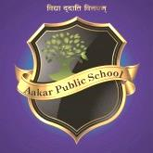
AAKAR PUBLIC SCHOOL

Annual Examination Date Sheet (2022-23)

